Chapter 3

Strategy and Technology: Concepts and Frameworks for Achieving Success

3.1 Introduction

Learning Objectives
- Define operational effectiveness and understand the limitations of technology-based competition leveraging this principle.
- Define strategic positioning and the importance of grounding competitive advantage in this concept.
- Understand the resource-based view of competitive advantage.
- List the four characteristics of a resource that might possibly yield sustainable competitive advantage.
Managers are confused, and for good reason. Management theorists, consultants, and practitioners often vehemently disagree on how firms should craft tech-enabled strategy, and many widely read articles contradict one another. Headlines such as “Move First or Die” compete with “The First-Mover Disadvantage.” A leading former CEO advises, “destroy your business,” while others suggest firms focus on their “core competency” and “return to basics.” The pages of the Harvard Business Review have declared, “IT Doesn’t Matter,” while a New York Times bestseller hails technology as the “steroids” of modern business. One pundit declares, “Data is the new Oil,” while others write, “There's no such thing as data,” and “Data isn't oil—it's sand.” And will AI be humanity’s demise or its savior?
Theorists claiming to have mastered the secrets of strategic management are contentious and confusing. But as a manager, the ability to size up a firm’s strategic position and understand its likelihood of sustainability is one of the most valuable and yet most difficult skills to master. Layer on thinking about technology—a key enabler to nearly every modern business strategy, but also a function often thought of as easily “outsourced”—and it’s no wonder that so many firms struggle at the intersection where strategy and technology meet. The business landscape is littered with the corpses of firms killed by managers who guessed wrong.
Developing strong strategic thinking skills is a career-long pursuit—a subject that can occupy tomes of text, a roster of courses, and a lifetime of seminars. While this chapter can’t address the breadth of strategic thought, it is meant as a primer on developing the skills for strategic thinking about technology. A manager who understands issues presented in this chapter should be able to see through seemingly conflicting assertions about best practices more clearly; be better prepared to recognize opportunities and risks; and be more adept at successfully brainstorming new, tech-centric approaches to markets.

The Danger of Relying on Technology
Firms strive for sustainable competitive advantage
Financial performance that consistently outperforms industry averages.
, financial performance that consistently outperforms their industry peers. The goal is easy to state, but hard to achieve. The world is so dynamic, with new products and new competitors rising seemingly overnight, that truly sustainable advantage might seem like an impossibility. New competitors and copycat products create a race to cut costs, cut prices, and increase features that may benefit consumers but erode profits industry-wide. Nowhere is this balance more difficult than when competition involves technology. The fundamental strategic question for increasingly digital businesses is, “How can I possibly compete when everyone can copy my technology and the competition is just a click away?” Put that way, the pursuit of sustainable competitive advantage seems like a lost cause.
But there are winners—big, consistent winners—empowered through their use of technology. How do they do it? In order to think about how to achieve sustainable advantage, it’s useful to start with two concepts defined by Michael Porter. A professor at the Harvard Business School and father of the value chain and the five forces concepts (refer to the sections later in this chapter), Porter is justifiably considered one of the leading strategic thinkers of our time.
According to Porter, the reason so many firms suffer aggressive, margin-eroding competition is because they’ve defined themselves according to operational effectiveness rather than strategic positioning. Operational effectiveness
Performing the same tasks better than rivals perform them.
refers to performing the same tasks better than rivals perform them. Everyone wants to be better, but the danger in operational effectiveness is “sameness.” When offerings are roughly the same, they are more commodity
A basic good that can be interchanged with nearly identical offerings by others—think milk, coal, orange juice, or, to a lesser extent, Windows PCs and Android phones. The more commoditized an offering, the greater the likelihood that competition will be based on price.
than differentiated. That often means that competition will focus on offering the lowest price, and this can pull down profits for all players that consumers see as basically equivalent in features. This risk is particularly acute in firms that rely on technology for competitiveness. After all, technology can be easily acquired. Buy the same stuff as your rivals, hire students from the same schools, copy the look and feel of competitor websites, reverse engineer their products, and you can match them. The fast follower problem
Exists when savvy rivals watch a pioneer’s efforts, learn from their successes and missteps, then enter the market quickly with a comparable or superior product at a lower cost before the first mover can dominate.
exists when savvy rivals watch a pioneer’s efforts, learn from their successes and missteps, then enter the market quickly with a comparable or superior product at a lower cost.
Since tech can be copied so quickly, followers can be fast, indeed. Groupon founder Andrew Mason claimed the daily deal service had spawned five hundred imitators within two years of launch. Venture capitalist Ben Evans notes that at the time of Facebook’s WhatsApp purchase, there were over fifty social apps in the Google Play store with over one million downloads each. A bunch of startups want you to sleep with them—at one time over 175 mattress firms operated in a crowded space made popular with disruptive models by Casper, Purple, and Leesa, Tuft & Needle, among others. Almost none of these firms manufactures their own products, and as CNBC states, “You can’t tell them apart.” When technology can be matched so quickly, it is rarely a source of competitive advantage. And this phenomenon isn’t limited to the Web.
Advertising is the price you pay for having an unremarkable product or service.
—Jeff Bezos, founder of Amazon.com
For the dangers of the fast follower problem, look at the competition between Snapchat and Facebook. Snapchat is considered the pioneer of many photo and video sharing features, such as “Stories,” location stickers, and augmented-reality
A technology that superimposes content, such as images and animation, on top of real-world images.
“selfie filters.” But Facebook properties, including Instagram, WhatsApp, Messenger, and the flagship Facebook app routinely mimic Snap features, implementing some in as little as four months after their appearance in Snapchat, leading TechCrunch to quip Facebook’s development mantra, formerly “Move Fast and Break Things” should now be “Move Last and Take Things.” Even worse, all these Facebook properties are larger than Snapchat, making Facebook the first stop for advertisers seeking to access the largest-possible audience. Snapchat’s growth tumbled 82 percent after Instagram Stories launched, and the firm posted a $2.2 billion loss in its first quarter as a public company.

Tech and Strategy Lessons from the Tragedy of TiVo
The digital video recorder (DVR) category was pioneered by TiVo, an early-to-market firm that created a best-in-class interface for recording television programs to a hard drive instead of tapes or discs. While DVR technology is now ubiquitous, TiVo's early role was so significant that for a time, its name had been used as a verb (e.g., “be sure to TiVo ‘Saturday Night Live’”) and was often used to describe all DVRs.
Figure 3.1 TiVo versus Cable Firms
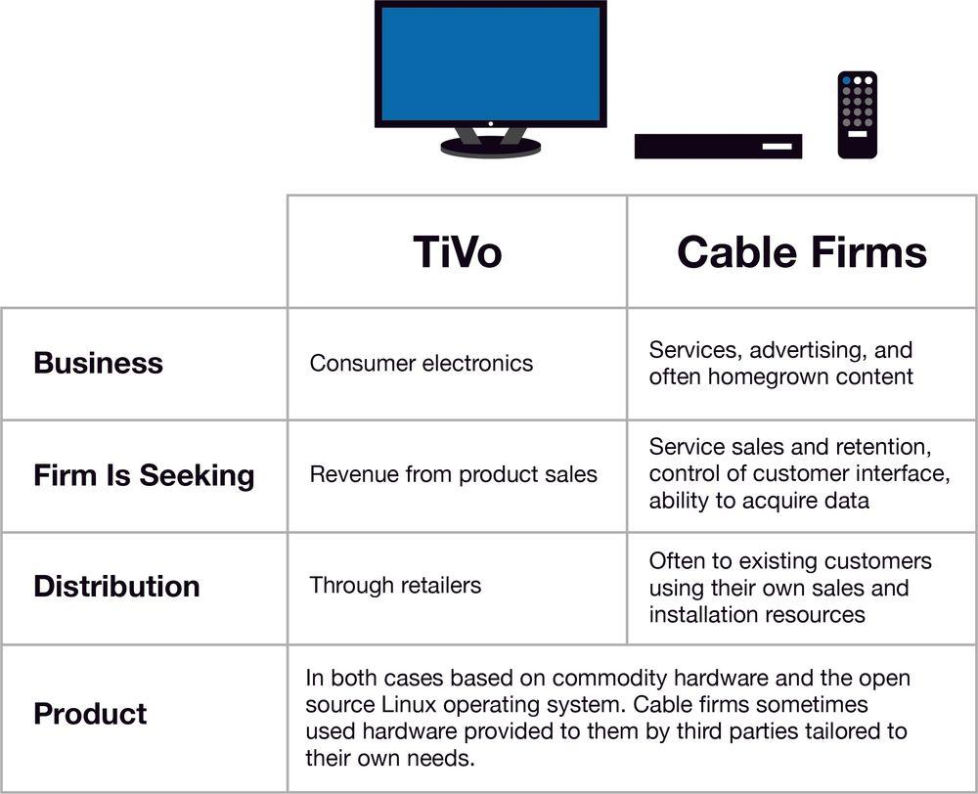
Source: John Gallaugher
Show long description
Yet despite pioneer TiVo's early category-defining name recognition, the firm was never a consumer electronics success. The company experienced losses during nearly every year it operated as an independent publicly traded firm. TiVo was eventually acquired by Rovi, a firm that rebranded as TiVo, and which was eventually acquired by Xperi in a deal largely focused on patents. Indeed, the few years when TiVo had reported a profit were usually associated with legal victories rather than sales success.
Why did TiVo fail as a consumer electronics firm? Its technology was largely based on components available to rivals: off-the-shelf processors, commodity hard drives, and the open source Linux operating system. Rivals could enter the market with a fraction of the development time required had they needed to develop similar products from scratch. TiVo also found its biggest competition wasn’t from other consumer electronics firms, but rather from cable TV providers. These firms had a distribution channel and existing customer base that TiVo lacked. Want a DVR? The cable guy will install it for you. And these non-consumer electronics rivals were strongly motivated: both by fear of being displaced as the primary interface with their customers, and by the opportunity to collect data, that vital resource for digital-age competitive advantage that could be used in business decisions ranging from service offerings to advertising to content development.
The Flip Video camera is another example of technology alone offering little durable advantage. The pocket-sized video recorders used flash memory instead of magnetic storage. Flip cameras grew so popular that Cisco bought Flip parent Pure Digital for $590 million. The problem was that digital video features were easy to copy, and constantly falling technology costs (refer to Chapter 6 “Moore’s Law and More: Fast/Cheap Computing and What This Means for the Manager”) allowed rivals to embed video into their products. Later that same year, Apple (and other firms) began including video capture as a feature in their music players and phones. Why carry a Flip when one pocket device can do everything? The Flip business barely lasted two years. Cisco killed the division, taking a more than half-billion-dollar spanking in the process.
Operational effectiveness is critical. Firms must invest in techniques to improve quality, lower cost, and design efficient customer experiences. But for the most part, these efforts can be matched. Because of this, operational effectiveness is usually not sufficient to yield sustainable dominance over the competition. In contrast to operational effectiveness, strategic positioning
Performing different tasks than rivals, or the same tasks in a different way.
refers to performing different activities from those of rivals, or the same activities in a different way. Technology itself is often very easy to replicate, and those assuming advantage lies in technology alone may find themselves in a profit-eroding arms race with rivals able to match their moves step by step. But while technology can be copied, technology can also play a critical role in creating and strengthening strategic differences—advantages that rivals will struggle to match.

But What Kinds of Differences?
The principles of operational effectiveness and strategic positioning are deceptively simple. But while Porter claims strategy is “fundamentally about being different,” how can you recognize whether your firm’s differences are special enough to yield sustainable competitive advantage?
An approach known as the resource-based view of competitive advantage
The strategic thinking approach suggesting that if a firm is to maintain sustainable competitive advantage, it must control an exploitable resource, or set of resources, that have four critical characteristics. These resources must be (1) valuable, (2) rare, (3) imperfectly imitable, and (4) nonsubstitutable.
can help. The idea here is that if a firm is to maintain sustainable competitive advantage, it must control a set of exploitable resources that have four critical characteristics. These resources must be (1) valuable, (2) rare, (3) imperfectly imitable (tough to imitate), and (4) nonsubstitutable. Having all four characteristics is key. Miss value and no one cares what you’ve got. Without rareness, you don’t have something unique. If others can copy what you have, or others can replace it with a substitute, then any seemingly advantageous differences will be undercut.
Strategy isn’t just about recognizing opportunity and meeting demand. Resource-based thinking can help you avoid the trap of carelessly entering markets simply because growth is spotted. The telecommunications industry learned this lesson in a very hard and painful way. With the explosion of the Internet it was easy to see that demand to transport Web pages, e-mails, MP3s, video, and everything else you can turn into ones and zeros, was skyrocketing.
Most of what travels over the Internet is transferred over long-haul fiber-optic cables, so telecom firms began digging up the ground and laying webs of fiberglass to meet the growing demand. Problems resulted because firms laying long-haul fiber didn’t fully appreciate that their rivals and new upstart firms were doing the exact same thing. By one estimate there was enough fiber laid to stretch from the Earth to the moon some 280 times! On top of that, a technology called dense wave division multiplexing (DWDM)
A technology that increases the transmission capacity (and hence speed) of fiber-optic cable. Transmissions using fiber are accomplished by transmitting light inside “glass” cables. In DWDM, the light inside fiber is split into different wavelengths in a way similar to how a prism splits light into different colors.
enabled existing fiber to carry more transmissions than ever before. The end result: These new assets weren’t rare, and each day they seemed to be less valuable.
For some firms, the transmission prices they charged on newly laid cable collapsed by over 90 percent. Established firms struggled, upstarts went under, and WorldCom became the biggest bankruptcy in U.S. history. The impact was also felt throughout all industries that supplied the telecom industry. Firms like Sun, Lucent, and Nortel, whose sales growth relied on big sales to telecom carriers, saw their value tumble as orders dried up. Estimates suggest that the telecommunications industry lost nearly $4 trillion in value in just three years, much of it due to executives who placed big bets on resources that weren’t strategic.

Nortel versus Beer: The Beer Wins
Figure 3.2 NORTEL—Now with Real DWDM
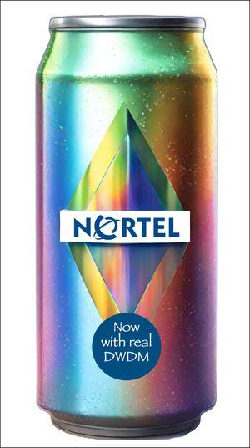
Source: Generated by John Gallaugher via Canva
There's a sad but popular tale among Nortel investors that provides a cautionary example of the dangers of following crowds during periods of hype—especially when one doesn't fully understand technology and market dynamics. It goes like this: Nortel, one of the dominant firms providing telecom equipment during the early Internet build-out, saw its value run up tremendously. At Nortel's height, the firm’s share price had gone through many splits and was worth $124.50, with an overall market cap above $380 billion. Investors who didn't get out when the price was up were in a world of hurt. Nortel's share price at bankruptcy was just $0.39. If you were faced with the option to either spend $1,000 in Nortel stock at its hype peak versus $1,000 on beer, you'd have more money from drinking all the beer and returning the empties than you would from your investment in Nortel.

Key Takeaways
- Technology can be easy to copy, and technology alone rarely offers sustainable advantage.
- Firms that leverage technology for strategic positioning use technology to create competitive assets or ways of doing business that are difficult for others to copy.
- True sustainable advantage comes from assets and business models that are simultaneously valuable, rare, difficult to imitate, and for which there are no substitutes.

3.2 Powerful Resources

Learning Objectives
- Understand that technology is often critical to enabling competitive advantage, and provide examples of firms that have used technology to organize for sustained competitive advantage.
- Understand the value chain concept and be able to examine and compare how various firms organize to bring products and services to market.
- Recognize the role technology can play in crafting an imitation-resistant value chain, as well as when technology choice may render potentially strategic assets less effective.
- Define the following concepts: brand, scale, data and switching cost assets, differentiation, network effects, and distribution channels.
- Understand and provide examples of how technology can be used to create or strengthen the resources mentioned above.
Management has no magic bullets. There is no exhaustive list of key resources that firms can look to in order to build a sustainable business. And recognizing a resource doesn’t mean a firm will be able to acquire it or exploit it forever. But being aware of major sources of competitive advantage can help managers recognize an organization’s opportunities and vulnerabilities, and can help them brainstorm winning strategies. Also, these assets rarely exist in isolation. Oftentimes, a firm with an effective strategic position can create an arsenal of assets that reinforce one another, creating advantages that are particularly difficult for rivals to successfully challenge.

Imitation-Resistant Value Chains
While many of the following resources are considered in isolation, the strength of any advantage can be far more significant if firms are able to leverage several of these resources in a way that makes each stronger and makes the firm’s way of doing business more difficult for rivals to match. Firms that craft an imitation-resistant value chain
A way of doing business that competitors struggle to replicate and that frequently involves technology in a key enabling role.
have developed a way of doing business that others will struggle to replicate, and in nearly every successful effort of this kind, technology plays a key enabling role. The value chain
The set of activities through which a product or service is created and delivered to customers.
is the set of interrelated activities that brings products or services to market (refer to below). If you read the earlier case on Zara and compare it to rivals, there are differences across every element. But most importantly, the elements in Zara's value chain work together to create and reinforce competitive advantages that others cannot easily copy. Incumbents trying to copy the firm would be straddled
In strategic management, this refers to a firm's attempt to occupy more than one position, while failing to match the benefits of a more efficient, singularly focused rival.
across two business models, unable to reap the full advantages of either. And late-moving pure-play rivals will struggle, as Zara's lead time allows the firm to develop brand, scale, data, and other advantages that newcomers lack (refer to below for more on these resources).

Key Framework: The Value Chain
The value chain is the “set of activities through which a product or service is created and delivered to customers.” There are five primary components of the value chain and four supporting components. The primary components are:
- Inbound logistics—getting needed materials and other inputs into the firm from suppliers
- Operations—turning inputs into products or services
- Outbound logistics—delivering products or services to consumers, distribution centers, retailers, or other partners
- Marketing and sales—customer engagement, pricing, promotion, and transaction
- Support—service, maintenance, and customer support
The secondary components are:
- Firm infrastructure—functions that support the whole firm, including general management, planning, IS, and finance
- Human resource management—recruiting, hiring, training, and development
- Technology/research and development—new product and process design
- Procurement—sourcing and purchasing functions
While the value chain is typically depicted as it’s displayed in Figure 3.3, goods and information don’t necessarily flow in a line from one function to another. For example, an order taken by the marketing function can trigger an inbound logistics function to get components from a supplier, operations functions (to build a product if it’s not available), or outbound logistics functions (to ship a product when it’s available). Similarly, information from service support can be fed back to advise research and development (R&D) in the design of future products.
When a firm has an imitation-resistant value chain—one that’s tough for rivals to copy in a way that yields similar benefits—then a firm may have a critical competitive asset. From a strategic perspective, managers can use the value chain framework to consider a firm’s differences and distinctiveness compared to rivals. If a firm’s value chain can’t be copied by competitors without engaging in painful trade-offs, or if the firm’s value chain helps to create and strengthen other strategic assets over time, it can be a key source for competitive advantage. Many of the examples used in this book, including FreshDirect, Amazon, and Zara, illustrate this point.
Figure 3.3 The Value Chain
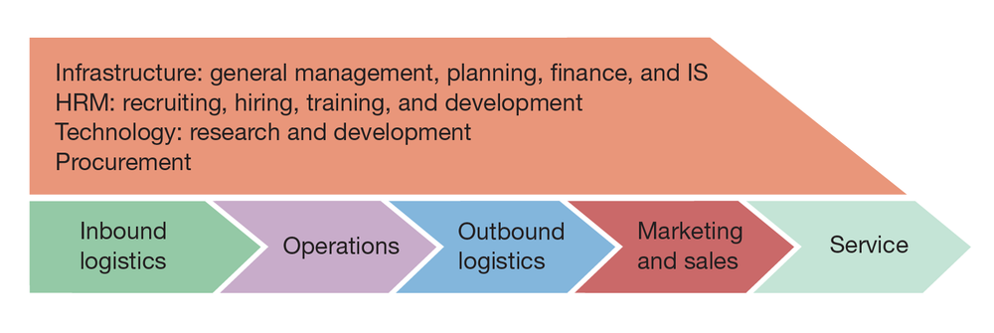
Source: John Gallaugher
Show long description
An analysis of a firm’s value chain can also reveal operational weaknesses, and technology is often of great benefit to improving the speed and quality of execution. Firms can often buy software to improve things, and tools such as supply chain management (SCM; linking inbound and outbound logistics with operations), customer relationship management (CRM; supporting sales, marketing, and in some cases R&D), and enterprise resource planning software (ERP; software implemented in modules to automate the entire value chain) can have a big impact on more efficiently integrating the activities within the firm, as well as with its suppliers and customers. But remember, these software tools can be purchased by competitors, too. While valuable, such software may not yield lasting competitive advantage if it can be easily matched by competitors as well.
There are other potential dangers in using third-party software to automate critical tasks. If a firm adopts software that changes a unique process into a generic one, it may have co-opted a key source of competitive advantage, particularly if other firms can buy the same stuff. This isn’t a problem with something like accounting software. Accounting processes are standardized and accounting isn’t a source of competitive advantage, so most firms buy rather than build their own accounting software. But using packaged, third-party SCM, CRM, and ERP software typically requires adopting a very specific way of doing things, using software and methods that can be purchased and adopted by others. Many of the firms covered in this text, including Inditex, Netflix, and Amazon, have elected to develop their own proprietary software solutions in large part because they see their uniqueness in certain operations as key to creating difficult-to-imitate competitive advantages.

Dell’s Struggles: Nothing Lasts Forever
Michael Dell enjoyed an extended run that took him from assembling PCs in his dorm room as an undergraduate at the University of Texas at Austin to heading the largest PC firm on the planet. For years Dell’s super-efficient, vertically integrated manufacturing (where it built its own PCs rather than outsourcing manufacturing, like nearly all competitors) and direct-to-consumer sales combined to help the firm earn seven times more profit on its own systems when compared with comparably configured rival PCs. And since Dell PCs were usually cheaper, too, the firm could often start a price war and still have better overall margins than rivals.
But then Dell’s killer model, one that had become a staple case study in business schools worldwide, began to lose steam. Nearly two decades of observing Dell had allowed the contract manufacturers serving Dell’s rivals to improve manufacturing efficiency. Component suppliers chose to locate near contract manufacturers, and assembly times fell dramatically. And as the cost of computing fell, the price advantage Dell enjoyed over rivals also shrank in absolute terms. That meant savings from buying a Dell weren’t as big as they once were. On top of that, the direct-to-consumer model also suffered when sales of notebook PCs outpaced the more commoditized desktop market. Notebooks can be considered to be more differentiated than desktops, and customers often want to compare products in person—lift them, type on keyboards, and view screens—before making a purchase decision, leading Dell to work with retailers instead of being direct-only. In time, these shifts knocked Dell from its ranking as the world’s number one PC manufacturer.
Dell’s struggles as computers, customers, and the product mix change all underscore the importance of continually assessing a firm’s strategic position among changing market conditions. There is no guarantee that today’s winning strategy will dominate forever. As you study firms including FreshDirect, Zara, Netflix, and others, it’s important to remember that the advantages that were sustainable for years in earlier competition might not line up with market realities and the competitive environment going forward.

Brand
A firm’s brand
The symbolic embodiment of all the information connected with a product or service.
is the symbolic embodiment of all the information connected with a product or service, and a strong brand can also be an exceptionally powerful resource for competitive advantage. Consumers use brands to lower search costs, so having a strong brand is particularly vital for firms hoping to be the first online stop for consumers. Want to buy a book online? Auction a product? Search for information? Which firm would you visit first? Almost certainly Amazon, eBay, or Google. But how do you build a strong brand? It’s not just about advertising and promotion. First and foremost, customer experience counts. A strong brand proxies quality and inspires trust, so if consumers can’t rely on a firm to deliver as promised, they’ll go elsewhere. As an upside, tech can play a critical role in rapidly and cost-effectively strengthening a brand. If a firm performs well, consumers can often be enlisted to promote a product or service (so-called viral marketing
Leveraging consumers to promote a product or service.
). Firms that grew to gargantuan size before committing any substantial investment on advertising include Google, Skype, eBay, Facebook, LinkedIn, Twitter, and YouTube. Social services like Facebook and Twitter are viral marketing machines. Instagram, Pinterest, and Spotify are just some of the firms that have built thriving businesses with millions of followers by increasing its public awareness through social sharing. Early customer accolades for a novel service often mean that positive press (a kind of free advertising) will also likely follow.
But show up late and you may end up paying much more to counter an incumbent’s place in the consumer psyche. Google’s brand is so strong that it has become a verb, and the cost to challenge it is astonishingly high. Yahoo! and Microsoft’s Bing each spent $100 million on Google-challenging branding campaigns, but the early results of these efforts seemed to do little to grow share at Google’s expense. Branding is difficult, but if done well, even complex tech products can establish themselves as killer brands. Consider that Intel has taken an ingredient product that most people don’t understand, the microprocessor, and built a quality-conveying name recognized by computer users worldwide.

Scale
Many firms gain advantages as they grow in size. Advantages related to a firm’s size are referred to as scale advantages
Advantages related to size.
. Businesses benefit from economies of scale
When costs can be spread across increasing units of production or in serving multiple customers. Businesses that have favorable economies of scale (like many Internet firms) are sometimes referred to as being highly scalable.
when the cost of an investment can be spread across increasing units of production or in serving a growing customer base. Firms that benefit from scale economies as they grow are sometimes referred to as being scalable. Many Internet and tech-leveraging businesses are highly scalable since, as firms grow to serve more customers with their existing infrastructure investment, profit margins improve dramatically.
Consider that in just one year during the firm’s early growth, the Internet firm Blue Nile sold as many diamond rings with just 115 employees and one website as a traditional jewelry retailer would sell through 116 stores. And with lower operating costs, Blue Nile can sell at prices that brick-and-mortar stores can’t match, attracting even more customers and further fueling its advantages in economies of scale. Profit margins improve as the costs to run the firm’s single website and operate its one warehouse are spread across increasing jewelry sales. The firm has begun to experiment with “web rooms”—consumer-education–focused storefronts that carry samples for inspection. “Web rooms” operate leanly with no for-sale inventory, no staff working for commission, and even in-store sales are handled from an iPad. The no-pressure, lean, multichannel approach and a thirty-day money-back guarantee help first-time diamond buyers gain confidence, offering experiences and tools targeted at learning, inspection, and customization. The firm even encourages customers to comparison shop rivals with the Blue Nile app open, confident the firm’s prices, touted as 20 to 40 percent below traditional retailers’ prices, will beat the price of any rock certified by the industry-standard GIA ratings agency. And the firm’s “Dream Box” mobile app uses augmented reality to allow a customer to see how their hand will look with custom-designed Blue Nile bling. Blue Nile has helped fuel over half a million marriage proposals, making the firm the largest online jewelry retailer, by far. With cost economics stacked against traditional jewelry stores, it’s no wonder 465 of them closed in a single year during Blue Nile’s rise.
A growing firm may also gain bargaining power with its suppliers or buyers. Apple’s dominance of smartphone and tablet markets has allowed the firm to lock up 60 percent of the world’s supply of advanced touch-screen displays, and to do so with better pricing than would be available to smaller rivals. Similarly, for years eBay could raise auction fees because of the firm’s market dominance. Auction sellers who left eBay lost pricing power since fewer bidders on smaller, rival services meant lower prices.
The scale of technology investment required to run a business can also act as a barrier to entry, discouraging new, smaller competitors. Although Google was started by two Stanford students with borrowed computer equipment running in a dorm room, the firm today runs on an estimated 1.4 million servers. Any rival wanting to copy Google's model would need some serious coin. The same dynamic is playing out in generative AI. The cost to train modern generative AI models is upward of $5 million—well above the average seed-round investment in technology firms. And costs to run these businesses can also be high—OpenAI, the firm behind ChatGPT, is estimated to have well over $40 million in tech costs each month just from users asking it questions. This is one of the reasons OpenAI rushed to accept $13 billion from Microsoft—a firm that now controls 49 percent of OpenAI, and that is the exclusive home for the company's AI models. A rival firm, Anthropic, started by ChatGPT alumni, raised over $1 billion in capital, and Amazon may invest $4 billion in total. Any firm wanting to compete with these emerging giants today will need to raise an enormous amount of capital and almost certainly seek a partnership like OpenAI has with Microsoft. The investments being made by Google and OpenAI would be cost prohibitive for almost any newcomer to justify.

Switching Costs and Data
Switching costs
The cost a consumer incurs when moving from one product to another. It can involve actual money spent (e.g., buying a new product) as well as investments in time, any data loss, and so forth.
exist when consumers incur an expense to move from one product or service to another. Tech firms often benefit from strong switching costs that cement customers to their firms. Users invest their time learning a product, entering data into a system, creating files, and buying supporting programs or manuals. These investments may make them reluctant to switch to a rival’s effort.
Similarly, firms that seem dominant but that don’t have high switching costs can be rapidly trumped by strong rivals. Netscape once controlled more than 80 percent of the market share in Web browsers, but when Microsoft began bundling Internet Explorer with the Windows operating system and (through an alliance) with America Online (AOL), Netscape’s market share plummeted. Customers migrated with a mouse click as part of an upgrade or installation. Learning a new browser was a breeze, and with the Web’s open standards, most customers noticed no difference when visiting their favorite websites with their new browser.

Sources of Switching Costs
- Learning costs: Switching technologies may require an investment in learning a new interface and commands.
- Information and data: Users may have to reenter data, convert files or databases, or even lose earlier contributions on incompatible systems.
- Financial commitment: Can include investments in new equipment, the cost to acquire any new software, consulting, or expertise, and the devaluation of any investment in prior technologies no longer used.
- Contractual commitments: Breaking contracts can lead to compensatory damages and harm an organization’s reputation as a reliable partner.
- Search costs: Finding and evaluating a new alternative costs time and money.
- Loyalty programs: Switching can cause customers to lose out on program benefits. Think frequent purchaser programs that offer “miles” or “points” (all enabled and driven by software).
It is critical for challengers to realize that in order to win customers away from a rival, a new entrant must not only demonstrate to consumers that an offering provides more value than the incumbent, but also ensure that their value added exceeds the incumbent’s value plus any perceived customer switching costs (refer to Figure 3.4). If it’s going to cost you and be inconvenient, there’s no way you’re going to leave unless the benefits are overwhelming.
Data can be a particularly strong switching cost for firms leveraging technology. A customer who enters her profile into Facebook, movie preferences into Netflix, or grocery list into FreshDirect may be unwilling to try rivals—even if these firms are cheaper or offer more features—if moving to the new firm means she’ll lose information feeds, recommendations, and time savings provided by the firms that already know her well. Fueled by scale over time, firms that have more customers and have been in business longer can gather more data, and many can use this data to improve their value chain by offering more accurate demand forecasting or product recommendations.
In commodity industries, data is increasingly the only substantive differentiator. Consider financial services, where all firms face the same regulation and can employ the same technologies with the same trading methods on the same securities. Forbes has reported that executives in financial services firms see the intelligent use of data and analytics as developing into the only source of differentiation in their industry. This also underscores how tightly various competitive resources are intertwined. The data asset isn’t created in isolation. Larger firms (i.e., firms with scale) can acquire more data, while firms that have been in business longer and that enjoy longer customer retention rates (i.e., lower churn) can gather more data on individual customers, as well.
Figure 3.4 Value of Service and Switching Costs
As demonstrated in the graphic, in order to win customers from an established incumbent, a late-entering rival must offer a product or service that not only exceeds the value offered by the incumbent, but also exceeds the incumbent’s value and any customer switching costs.
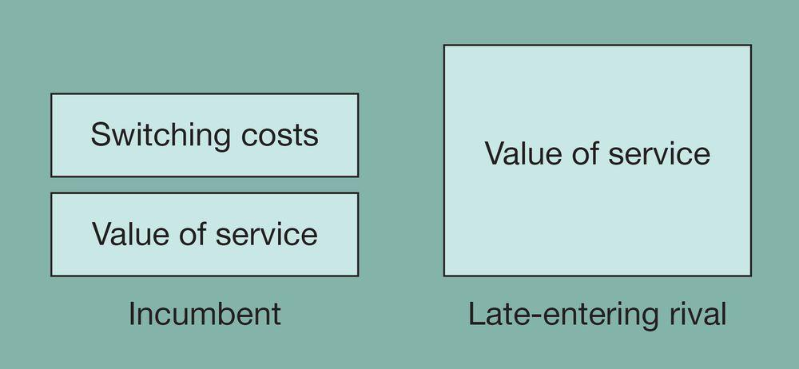
Source: John Gallaugher

Differentiation
Commodities are products or services that are nearly identically offered from multiple vendors. Consumers buying commodities are highly price-focused since they have so many similar choices. In order to break the commodity trap, many firms leverage technology to differentiate their goods and services. Data is not only a switching cost, it also plays a critical role in differentiation. Each time a visitor returns to Amazon, the firm uses browsing records, purchase patterns, and product ratings to present a custom home page featuring products that the firm hopes the visitor will like. Customers value the experience they receive at Amazon so much that the firm received the highest score ever recorded on the University of Michigan’s American Customer Satisfaction Index (ACSI). The score was not just the highest performance of any online firm; it was the highest ranking that any service firm in any industry had ever received.
Apple is another firm that has distinguished itself through differentiation. Unlike rival offerings from Microsoft and Google, Apple mobile and computer operating systems only run on Apple hardware. This allows the firm to tightly integrate the experience across Apple products. Apple systems consistently receive high customer satisfaction ratings, are considered easier to use, are more secure, and have fewer privacy issues. While Apple’s market share in computer operating systems is less than that of Microsoft Windows, and Apple’s worldwide smartphone market share is less than that of Google’s Android, Apple’s differentiation (and its ability to avoid price-eroding, commodity-based competition of other hardware rivals) has helped make Tim Cook’s firm the most profitable and valuable company in the United States.

Network Effects
Facebook is by far the dominant social network worldwide. Microsoft Windows has a 90 percent market share in operating systems. eBay has an 80 percent share of online auctions. Why are these firms so dominant? This is largely due to the concept of network effects
Also known as Metcalfe’s Law, or network externalities. When the value of a product or service increases as its number of users expands.
(refer to Chapter 10 “Platforms, Network Effects, and Competing in a Winner-Take-All World”). Network effects (sometimes called network externalities or Metcalfe’s Law) exist when a product or service becomes more valuable as more people use it. If you’re the first person with a Facebook account, then Facebook isn’t very valuable. But with each additional user, there’s one more person to communicate with. A firm with a big network of users might also see value added by third parties. Apple’s iOS devices (the iPhone, iPod touch, and iPad) and Google’s Android dominate rivals from Microsoft and BlackBerry in part because Apple and Google have tens of thousands more apps that run on and enhance these devices, and most of these apps are provided by firms other than Apple and Google. Third-party add-on products, books, magazines, or even skilled labor are all attracted to networks of the largest number of users, making dominant products even more valuable.
Switching costs also play a role in determining the strength of network effects. Tech user investments often go far beyond simply the cost of acquiring a technology. Users spend time learning a product; they buy add-ons, create files, and enter preferences. Because no one wants to be stranded with an abandoned product and lose this additional investment, users may choose a technically inferior product simply because the product has a larger user base and is perceived as having a greater chance of being offered in the future. The virtuous cycle of network effects doesn’t apply to all tech products, and it can be a particularly strong asset for firms that can control and leverage a leading standard. Consider Apple’s iPhone and iPad with their closed systems versus the once-dominant but now rarely used Netscape browser, which was almost entirely based on open standards. Yet, in some cases where network effects are significant, they can create winners so dominant that firms with these advantages enjoy a near-monopoly hold on a market.

OpenTable: Network Effects That Fill Restaurants’ Seats
Network effects earned through making a market more efficient are at the center of OpenTable’s dominance in restaurant reservations. By getting between restaurants and their customers, and adding lots of value along the way, OpenTable has built the world’s largest online restaurant reservation system, one so dominant it is effectively a monopoly. OpenTable can get you a reservation at over 60,000 restaurants worldwide.
The system delivers high value to the industry by exposing inventory and lowering search costs, thereby reducing frustration. Customers are attracted to the service that has the most restaurants, and restaurants are attracted to the service with the most customers. Strategists call this a two-sided market, and the strong network effects that result often crown one clear winner ahead of all other competitors. OpenTable’s captive audience of restaurants and diners effectively creates a new distribution channel for introducing all sorts of additional value-added services, including loyalty programs to encourage repeat use and payments to lower customer wait times and free up more table inventory. The firm’s industry dominance is so complete that Booking Holdings Inc. (a firm that includes over half a dozen brands, including Booking.com, Rentalcars.com, and Kayak.com in addition to Priceline.com) offered $2.6 billion to acquire the firm.
Figure 3.5 OpenTable Reservations
Roughly half of all reservations are made from the firm’s mobile apps. Network effects make OpenTable the first place diners go for reservations. It is also the first choice for restaurants seeking diners. This dynamic helped the firm build a business valued at over $2.6 billion.
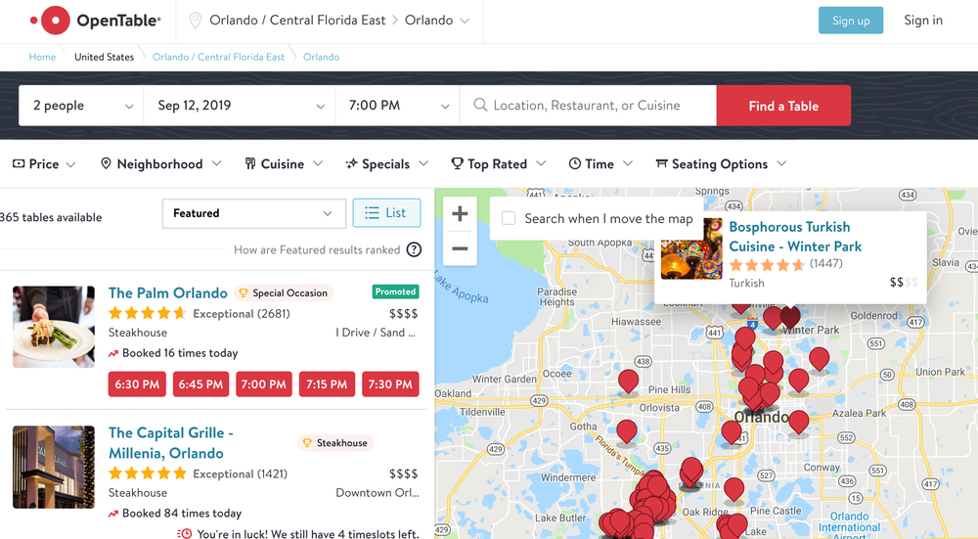
Source: OpenTable

Distribution Channels
If no one sees your product, then it won’t even get considered by consumers. So distribution channels
The path through which products or services get to customers.
—the path through which products or services get to customers—can be critical to a firm’s success.
Apple Stores show firm-crafted retail distribution channels at their most effective. As mentioned earlier, one of Apple’s key competitive strengths lies in the firm’s differentiation versus rival products; however, firms offering highly differentiated offerings may face difficulty convincing potential customers of a product’s unfamiliar benefits. Apple gear at a Best Buy might face price or simple feature checklist comparisons. However, Apple products offered at the Apple Store give firm-trained employees an opportunity to present advantages of the company’s unique products, how they work together, and free on-site customer support. While many in the business press thought the Apple Store would be a dismal failure (it was introduced at a time when PC maker Gateway was shuttering its own failed retail experiment), for Apple this formula has resulted in the single most successful retail chain in the United States on a sales-per-square-foot basis. Apple Store sales dwarf not just consumer electronics categories, but also clothing retailers, high-end jewelers, and every other store regardless of category.
Table 3.1 Top Retailers: Sales per Square Foot
Rank | Firm | Sales/Sq. Ft. ($)
1 | Apple Stores | 5,546
2 | Generation Next Franchise Brands (self-serve food and printing kiosks found in malls, airports, and theaters) | 3,970
3 | Murphy USA (gas and convenience store) | 3,721
4 | Tiffany & Co. (jewelry) | 2,951
5 | Lululemon (apparel) | 1,560
Source: Data from L. Thomas, “Bucks from Bricks: These Retailers Make the Most Money per Square Foot on Their Real Estate,” CNBC, July 29, 2017.
Apple also leveraged its iTunes platform as a distribution channel to launch the Apple Music subscription service. Just nine months after launching Apple Music, the firm had attracted over 13 million paying subscribers to its streaming service. Subscribing was easy, as anyone who had iTunes and who had bought something with Apple could sign up with a few taps, no download required. Today Apple has over 88 million subscribers worldwide, and while Spotify has more subscribers overall, Apple Music has, at times, overtaken its Swedish rival in the United States in terms of paying subscribers. Apple also has an additional distribution advantage that Spotify doesn’t—bundling
Selling products available separately as a single package. Bundling can be especially effective when a software product or service is included with a hardware product. Bundling can also be tricky as it can raise a risk of unfair competitive practices, especially if a firm has a monopoly or otherwise large amount of market control.
. Apple Music is now included as part of a more expensive AppleOne subscription, which also includes Apple TV+, Apple Arcade (Games), Apple News+, Apple Fitness+, and iCloud+ storage. Apple Music is also the default streaming option that comes with every new Mac and iOS device.
Technology also opens up opportunities to leverage products provided by others to create new distribution channels to reach customers. Many firms offer APIs
Programming hooks, or guidelines, published by firms that tell other programs how to get a service to perform a task such as send or receive data. For example, Amazon provides APIs to let developers write their own applications and websites that can send the firm orders.
(application programming interfaces), essentially programming hooks that allow other firms to tap into their services. By publishing APIs, Uber has managed to add its service to apps and websites provided by United Airlines, OpenTable, and Tripadvisor.
Users can also be recruited to create new distribution channels for your products and services (usually for a cut of the take). You may have visited websites that promote books sold on Amazon. Website operators do this because Amazon gives them a percentage of all purchases that come in through these links. Amazon now has over one million of these “associates” (the term the firm uses for its affiliates
Third parties that promote a product or service, typically in exchange for a cut of any sales.
), yet it only pays them if a promotion gains a sale. Google similarly receives some $33 billion of its ad revenue not from search ads, but from its ad network that distributes advertisements to third-party sites ranging from lowly blogs to the New York Times, splitting the take with content providers.
Being dependent on distribution channels provided by other firms can present challenges if distribution partners suddenly decide to cut you off. When the iPhone was introduced, Google was Apple’s exclusive map provider. However, Apple eventually launched its own map service, kicking out Google as a default option and relegating it to an iOS also-ran. Two years after the change, fewer than one in six iOS users had installed the Google Maps app on their devices, even though Apple’s mapping product was initially considered inferior. Fear of losing out on access to iPhone users is one reason why Google reportedly spends over $26 billion a year in a combination of flat fee and ad revenue to be the default search engine for Apple products. Over half of all Google searches come from Apple devices. One challenge for very large firms that have saturated markets and multibillions in revenues is to find new venues for growth, but Apple has regularly leveraged its platform to surface new business opportunities. Also note that buying its way into market access isn’t the only alternative—Google has created its own ways to reach customers. Even though Microsoft and Apple embed their browsers with their operating systems, Google’s Chrome remains the most widely used Web browser in the world, Gmail has emerged as the top free e-mail alternative, and the firm’s Android OS is even more popular worldwide than iOS.
The ability to distribute products and services by bundling them with existing offerings can be a key advantage. Apple’s services business (think the AppleOne services mentioned above) now account for about one-quarter of the firm’s total revenue—more than the iPad and wearables business. But beware: Sometimes these distribution channels can provide firms with such an edge that international regulators have stepped in to try to provide a more level playing field. European regulators have forced Microsoft to unbundle the firm’s own Web browser and media player from Windows, and Google has faced fines worldwide for allegedly favoring its own products in searches over those provided by rivals, with some wondering if regulators may demand the firm be broken up.
How Apple and Google Formed One of Tech’s Most Powerful Partnerships
Apple and Google’s businesses are deeply entangled, with Google reliant on Apple for distribution and Apple gaining major profits through its deals with Google. This video is informative, but the stats are out of date. In a recent trial it was revealed that Google pays Apple 36 percent of its search ad revenue for ads that come through Apple devices. This amounts to over $26 billion a year. Are these deals anticompetitive? And if they were shut down, would Apple be allowed to create its own search alternative, offering yet another service inside of its walled garden?

What about Patents?
Intellectual property protection can be granted in the form of a patent for those innovations deemed to be useful, novel, and nonobvious. In the United States, technology and (more controversially with certain restrictions) even business methods (processes) can be patented, typically for periods of twenty years from the date of patent application. Firms that receive patents have some degree of protection from copycats that try to identically mimic their products and methods.
The patent system is often considered to be unfairly stacked against startups. U.S. litigation costs in a single patent case average about $5 million, and a few months of patent litigation can be enough to sink an early-stage firm. Large firms can also be victims. Non-practicing entities
Commonly known as patent trolls, these firms make money by acquiring and asserting patents, rather than bringing products and services to market.
(NPEs), more commonly known as patent trolls, hold intellectual property not with the goal of bringing novel innovations to market but instead in hopes that they can sue or extort large settlements from others. A $612 million settlement paid by BlackBerry (at the time known as Research in Motion) to the little-known holding company NTP is often highlighted as an example of the pain trolls can inflict. Litigation threats are pushing rivals to cooperate in patent portfolio acquisition. Apple, EMC, Ericsson, Microsoft, RIM, and Sony pooled resources for a $4.5 billion purchase of some 6,000 patents formally held by the bankrupt telecom equipment firm Nortel.
Even if an innovation is patentable, that doesn’t mean that a firm has bulletproof protection. Some patents have been nullified by the courts upon later review (usually because of a successful challenge to the uniqueness of the innovation). Software patents are also widely granted, but notoriously difficult to defend. The U.S. Supreme Court unanimously ruled that simply taking an existing, well-known business method and applying technology to the process is no longer patent eligible. Also, in many cases, coders at competing firms can write substitute algorithms that aren’t the same, but accomplish similar tasks. For example, although Google’s PageRank search algorithms are fast and efficient, Microsoft, Yahoo!, and others now offer their own noninfringing search that presents results with an accuracy that many would consider on par with PageRank. Patents do protect tech-enabled operations innovations at firms like Netflix, and design innovations like the iPod click wheel. And because of patents that overlap with Google’s Android system and related mobile innovations, Microsoft actually makes more money from Samsung than from Skype, Windows Phone, and Xbox combined. Patents can be extremely important and even lucrative, but in a study of the factors that were critical in enabling firms to profit from their innovations, then Carnegie Mellon professor Wes Cohen found that patents were only the fifth most important factor. Secrecy, lead time, sales skills, and manufacturing all ranked higher.

Key Takeaways
- Technology can play a key role in creating and reinforcing assets for sustainable advantage by enabling an imitation-resistant value chain; strengthening a firm’s brand; collecting useful data and establishing switching costs; creating a network effect; creating or enhancing a firm’s scale advantage; enabling product or service differentiation; and offering an opportunity to leverage unique distribution channels.
- The value chain can be used to map a firm’s efficiency and to benchmark it against rivals, revealing opportunities to use technology to improve processes and procedures. When a firm is resistant to imitation, a superior value chain may yield sustainable competitive advantage.
- Firms may consider adopting packaged software or outsourcing value chain tasks that are not critical to a firm’s competitive advantage. A firm should be wary of adopting software packages or outsourcing portions of its value chain that are proprietary and a source of competitive advantage.
- Patents are not necessarily a surefire path to exploiting an innovation. Many technologies and business methods can be copied, so managers should think about creating assets like the ones previously discussed if they wish to create a truly sustainable advantage.
- Nothing lasts forever, and shifting technologies and market conditions can render once strong assets obsolete.

3.3 Barriers to Entry, Technology, and Timing

Learning Objectives
- Understand the relationship between timing, technology, and the creation of resources for competitive advantage.
- Argue effectively when faced with broad generalizations about the importance (or lack of importance) of technology and timing to competitive advantage.
- Recognize the difference between low barriers to entry and the prospects for the sustainability of new entrants’ efforts.
Some have correctly argued that the barriers to entry for many tech-centric businesses are low. This argument is particularly true for the Internet, where rivals can put up a competing website or deploy a rival app seemingly overnight. But it’s absolutely critical to understand that market entry is not the same as building a sustainable business, and just showing up doesn’t guarantee survival.
Platitudes like “follow, don’t lead” can put firms dangerously at risk, and statements about low entry barriers ignore the difficulty many firms will have in matching the competitive advantages of successful tech pioneers. Should Blockbuster have waited while Netflix pioneered? In a year in which Netflix profits were up sevenfold, Blockbuster lost more than $1 billion, and today Blockbuster is bankrupt. Yet by 2018, Netflix briefly surpassed Disney in market capitalization. Should Sotheby’s have dismissed seemingly inferior eBay? In the first three months of 2018, eBay made nearly half a billion dollars in profits. Sotheby’s lost $6.5 million and has since been taken private
As in “to go private” or “take a firm private.” Buying up a publicly traded firm’s shares. Usually done when a firm has suffered financially and when a turnaround strategy will first yield losses that would further erode share price. Firms (often called private equity, buyout, LBO, or leveraged buyout firms) that take another company private hope to improve results so that the company can be sold to another firm or they can reissue shares on public markets.
. Barnes & Noble waited seventeen months to respond to Amazon. By 2018, Amazon became only the second U.S. firm to reach a $1 trillion market cap. By comparison, in its last year as a publicly traded company, 2019, Barnes & Noble lost over $125 million and was taken private. At that time Amazon’s market cap was over 1,500 times greater than the premium price paid for Barnes & Noble. Today’s Internet giants are winners because in most cases they were the first to move with a profitable model and they were able to quickly establish resources for competitive advantage. With few exceptions, established offline firms have failed to catch up to today’s Internet leaders.
Timing and technology alone will not yield sustainable competitive advantage. Yet both of these can be enablers for competitive advantage. Put simply, it’s not the time lead or the technology; it’s what a firm does with its time lead and technology. True strategic positioning means that a firm has created differences that cannot be easily matched by rivals. Moving first pays off when the time lead is used to create critical resources that are valuable, rare, tough to imitate, and lack substitutes. Anything less risks the arms race of operational effectiveness. Build resources like brand, scale, network effects, switching costs, or other key assets and your firm may have a shot. But guess wrong about the market or screw up execution, and failure or direct competition awaits. It is true that most tech can be copied—there’s little magic in eBay’s servers, Intel’s processors, Oracle’s database software, or Microsoft’s operating systems that past rivals have not at one point improved upon. But the lead that each of these tech-enabled firms had was leveraged to create network effects, switching costs, and data assets, and helped build solid and well-respected brands.

But Google Arrived Late! Why Incumbents Must Constantly Consider Rivals
Gmail is the dominant e-mail provider today, but it took Google eight years to finally top early leaders Yahoo! Mail and Hotmail. Yahoo! and Hotmail were able to hold onto their lead in e-mail market share for several years after Gmail’s introduction, likely because these firms quickly matched and nullified Gmail’s most significant tech-based innovation (more free storage) before Google could inflict real damage. Perhaps Yahoo! had learned from prior errors. The firm’s earlier failure to respond to Google’s emergence as a credible threat in search advertising gave Sergey Brin and Larry Page the time they needed to build the planet’s most profitable Internet firm.
By some accounts, Google was actually the twenty-first notable firm to enter the Internet search market. Yahoo! (and many Wall Street analysts) saw search as a commodity—a service the firm had subcontracted out to other firms including AltaVista and Inktomi. Yahoo! saw no conflict in taking an early investment stake in Google or in using the firm for its search results. But Yahoo! failed to pay attention to Google’s advance. As Google’s innovations in technology, interface, and advertising remained unmatched over time, the firm was able to build its brand, scale, and advertising network (distribution channel) that grew from network effects because content providers and advertisers attract one another. These are all competitive resources that rivals have never been able to match.
Now Google (and Apple, too) are once again running from this playbook—turning the smartphone software market into what has become a two-horse race. Many rivals, including Microsoft, had been trying to create a mobile standard for years, but their technical innovations offered little durable strategic value. It wasn’t until app stores flourished, offered with a high-quality user experience, that dominant smartphone platforms emerged. Yes, Google and Apple arrived late, but nothing before them had created defensible strategic assets, and that left an opening.
Google’s ability to succeed after being late to the search and mobile party isn’t a sign of the power of the late mover; it’s a story about the failure of incumbents to monitor their competitive landscape, recognize new rivals, and react to challenging offerings. That doesn’t mean that incumbents need to respond to every potential threat. Indeed, figuring out which threats are worthy of response is the real skill here. Video rental chain Hollywood Video wasted over $300 million in an Internet streaming business years before high-speed broadband was available to make the effort work. But while Blockbuster avoided the balance sheet–cratering gaffes of Hollywood Video, the firm also failed to respond to Netflix—a new threat that had timed market entry perfectly (refer to Chapter 5 “Netflix: Sustaining Leadership in an Epic Shift from Atoms to Bits”).
Firms that quickly get to market with the “right” model can dominate, but it’s equally critical for leading firms to pay close attention to competition and innovate in ways that customers value. Take your eye off the ball and rivals may use time and technology to create strategic resources. Friendster was once known as the largest social network in the United States but has become virtually irrelevant today. And even the King of social, Facebook, has been tripped up. Zuckerberg’s slow-to-execute mobile strategy led to the rise of SnapChat, Instagram, and WhatsApp. Facebook eventually bought the latter two for $1 billion and $19 billion, respectively. Taking your eye off the competition can have a high price, indeed.

Key Takeaways
- It doesn’t matter if it’s easy for new firms to enter a market if these newcomers can’t create and leverage the assets needed to challenge incumbents.
- Beware of those who say, “IT doesn’t matter” or refer to the “myth” of the first mover. This thinking is overly simplistic. It’s not a time or technology lead that provides sustainable competitive advantage; it’s what a firm does with its time and technology lead. If a firm can use a time and technology lead to create valuable assets that others cannot match, it may be able to sustain its advantage. But if the work done in this time and technology lead can be easily matched, then no advantage can be achieved, and a firm may be threatened by new entrants.

3.4 Key Framework: The Five Forces of Industry Competitive Advantage

Learning Objectives
- Diagram the five forces of competitive advantage.
- Apply the framework to an industry, assessing the competitive landscape and the role of technology in influencing the relative power of buyers, suppliers, competitors, and alternatives.
Professor and strategy consultant Gary Hamel once wrote in a Fortune cover story that “the dirty little secret of the strategy industry is that it doesn’t have any theory of strategy creation.” While there is no silver bullet for strategy creation, strategic frameworks help managers describe the competitive environment a firm is facing. Frameworks can also be used as brainstorming tools to generate new ideas for responding to industry competition. If you have a model for thinking about competition, it’s easier to understand what’s happening and to think creatively about possible solutions.
One of the most popular frameworks for examining a firm’s competitive environment is Porter’s five forces
Also known as Industry and Competitive Analysis. A framework considering the interplay between (1) the intensity of rivalry among existing competitors, (2) the threat of new entrants, (3) the threat of substitute goods or services, (4) the bargaining power of buyers, and (5) the bargaining power of suppliers.
, also known as the Industry and Competitive Analysis. As Porter puts it, “analyzing [these] forces illuminates an industry’s fundamental attractiveness, exposes the underlying drivers of average industry profitability, and provides insight into how profitability will evolve in the future.” The five forces this framework considers are (1) the intensity of rivalry among existing competitors, (2) the threat of new entrants, (3) the threat of substitute goods or services, (4) the bargaining power of buyers, and (5) the bargaining power of suppliers (refer to Figure 3.6).
Figure 3.6 The Five Forces of Industry and Competitive Analysis
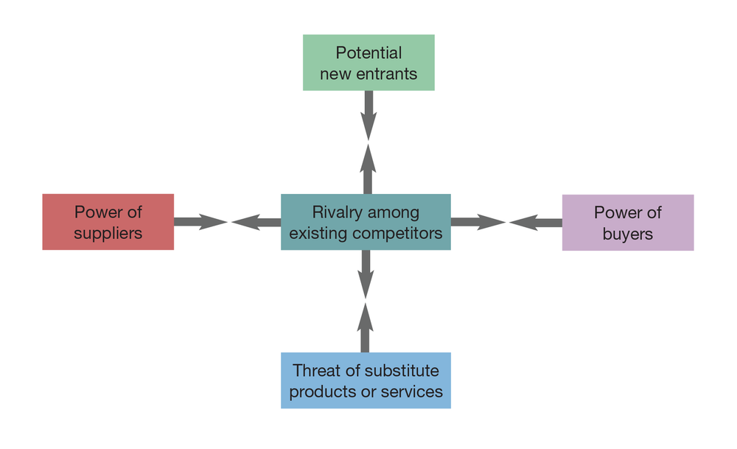
Source: John Gallaugher
New technologies can create jarring shocks in an industry. Consider how the rise of the Internet has impacted the five forces for music retailers. Traditional music retailers like Tower and Virgin found that customers were seeking music online. These firms scrambled to invest in new e-commerce channels out of what was perceived to be a necessity. Their intensity of rivalry increased because they not only competed based on the geography of where brick-and-mortar stores are physically located, they began to compete online as well. Investments online are expensive and uncertain, prompting some firms to partner with new entrants such as Amazon. Free from brick-and-mortar stores, Amazon, the dominant new entrant, has a highly scalable cost structure while the old brick-and-mortar guys were left straddling both online and offline models, unable to gain the efficiency of the singularly focused Amazon that ran lean, free of retail stores. Add to this the fact that in many ways the online buying experience is superior to what customers saw in stores. Customers can hear samples of almost all tracks, selection is seemingly limitless (the long tail phenomenon—see this concept illuminated in Chapter 5 “Netflix: Sustaining Leadership in an Epic Shift from Atoms to Bits”), and data is leveraged using collaborative filtering software to make product recommendations and assist in music discovery. Tough competition, but it gets worse because CD sales aren’t the only way to consume music. The process of buying a plastic disc now faces substitutes as digital music files become available on commercial music sites. Who needs the physical atoms of a CD filled with ones and zeros when you can buy the bits one song at a time? Or don’t buy anything and subscribe to a limitless library instead.
From a sound quality perspective, the substitute good of digital tracks purchased online is almost always inferior to their CD counterparts. To transfer songs quickly and hold more songs on a digital music player, tracks are encoded in a smaller file size than what you’d get on a CD, and this smaller file contains lower playback fidelity. But the additional tech-based market shock brought on by digital music players (particularly the iPod) has changed listening habits. The convenience of carrying thousands of songs trumps what most consider just a slight quality degradation. iTunes sales rose to make Apple the number one reseller of music, online or off. But Apple itself was hit by a substitute product—music streaming. Spotify started outside the United States, where licensing schemes were often more favorable and easier to obtain. To be clear, Apple Music is a giant, but it’s still the number two service behind early mover Spotify, despite all of Apple’s advantages. All this choice gives consumers (buyers) bargaining power. They demand cheaper prices and greater convenience.

ChatGPT Is Killing Stack Overflow
Keep your eye on the new substitute good—generative AI (GenAI), the technology used to generate answers in services like ChatGPT. Some wonder if one day users will turn to generative AI for answers rather than using search engines and clicking through links. If this happens, it would tank the most lucrative game in all of advertising—Internet search. While GenAI hasn’t yet eaten into Google’s search market share (Microsoft has seen no noticeable uptick since baking GPT into Bing), nor has it noticeably lowered visitors to major news sites, results on some niche sites have plummeted as GenAI becomes a clearly superior product. The programmer Q&A site Stack Overflow saw a 50 percent drop off in the months following the introduction of ChatGPT. Less than a year after ChatGPT’s introduction, Stack Overflow’s parent had laid off nearly 30 percent of its workforce. ChatGPT is actually a very good (although not perfect) programmer and knows a lot of programming languages. Many programmers found they were likely to get better advice, quicker, by consulting ChatGPT than by searching through Stack Overflow’s many, many posts and dealing with its often hostile and sanctimonious seasoned posters who are quick to chastise users when a question has already been answered. It’s early days for GenAI, but massive disruption could follow as the technology presents a series of superior substitute offerings in a wide variety of industries.
Generative AI Is About to Reset Everything, and, Yes It Will Change Your Life, Forbes
Transcript
The Internet can also create models that strengthen the bargaining power of suppliers. Consider the rise of taxi services such as Uber. In the old model, cab firms own the right to run a taxi through the purchase of expensive medallions. Drivers work as independent contractors and pay a “shift fee” to lease the cab from the medallion-owning cab firms. Drivers pay gas and insurance, too, and all this expense can cost drivers $150 upward per twelve-hour shift. Because of this, it’s not uncommon for traditional cab drivers to run a shift where they can’t even cover their costs. By contrast, ride-sharing services cut out the medallion-owning middleman for anyone who could use their own car for transport, and the services often deliver enough fares to triple wages, all while offering fares that can (depending on the city and cab supply) undercut cab rates by 30 percent. According to the San Francisco Cab Drivers Association, one-third of its drivers ditched their registered cabs in a twelve-month span to drive for ride-sharing companies such as Uber and Lyft. In some cities where Uber operates, business for traditional cabs is down 35 to 40 percent. (For more about ride-sharing services, refer to Chapter 12 “The Sharing Economy, Collaborative Consumption, and Efficient Markets through Tech”.)
While it can be useful to look at changes in one industry as a model for potential change in another, it’s important to realize that the changes that impact one industry do not necessarily impact other industries in the same way. For example, it is often suggested that the Internet increases bargaining power of buyers and lowers the bargaining power of suppliers. This suggestion is true for some industries like auto sales and jewelry where the products are commodities and the price transparency
The degree to which complete information is available.
of the Internet counteracts a previous information asymmetry
A decision situation where one party has more or better information than its counterparty.
, where customers often didn’t know enough information about a product to bargain effectively. But it’s not true across the board.
In cases where network effects are strong or a seller’s goods are highly differentiated, the Internet can strengthen supplier bargaining power. The customer base of an antiques dealer used to be limited by how many likely purchasers lived within driving distance of a store. Now with eBay, the dealer can take a rare good to a global audience and have a much larger customer base bid up the price. Switching costs also weaken buyer bargaining power. Wells Fargo has found that customers who use online bill pay (where switching costs are high) are 70 percent less likely to leave the bank than those who don’t, suggesting that these switching costs help cement customers to the company even when rivals offer more compelling rates or services.
Tech plays a significant role in shaping and reshaping these five forces, but it’s not the only significant force that can create an industry shock. Government deregulation or intervention, political shock, and social and demographic changes can all play a role in altering the competitive landscape. Because we live in an age of constant and relentless change, managers need to continually visit strategic frameworks to consider any market-impacting shifts. Predicting the future is difficult, but ignoring change can be catastrophic.

Key Takeaways
- Industry competition and attractiveness can be described by considering the following five forces: (1) the intensity of rivalry among existing competitors, (2) the potential for new entrants to challenge incumbents, (3) the threat posed by substitute products or services, (4) the power of buyers, and (5) the power of suppliers.
- In markets where commodity products are sold, the Internet can increase buyer power by increasing price transparency.
- The more differentiated and valuable an offering, the more the Internet shifts bargaining power to sellers. Highly differentiated sellers that can advertise their products to a wider customer base can demand higher prices.
- A strategist must constantly refer to models that describe events impacting their industry, particularly as new technologies emerge.
- We’re still in the early days of generative AI, but it may present a compelling substitute good that can be trained to disrupt many services. ChatGPT is already blamed as a reason for programmer Q&A site Stack Overflow laying off nearly 30 percent of its workforce.

